Insert Symbol Here-Eh

Insert Symbol Here-Ah

Insert Symbol Here-S

Insert Symbol Here-M

Insert Symbol Here-O

Insert Symbol Here-H

Insert Symbol Here-N

Insert Symbol Here-L

Insert Symbol Here-Keh

Insert Symbol Here-Ch

Insert Symbol Here-I

Insert Symbol Here-V

Insert Symbol Here-R

Insert Symbol Here-F

Insert Symbol Here-P-Need to get a symbol draft for this!

Insert Symbol Here-Beh

Insert Symbol Here-Ee

Insert Symbol Here-D

Insert Symbol Here-G

Insert Symbol Here-U

***Current Draft of Symbols***

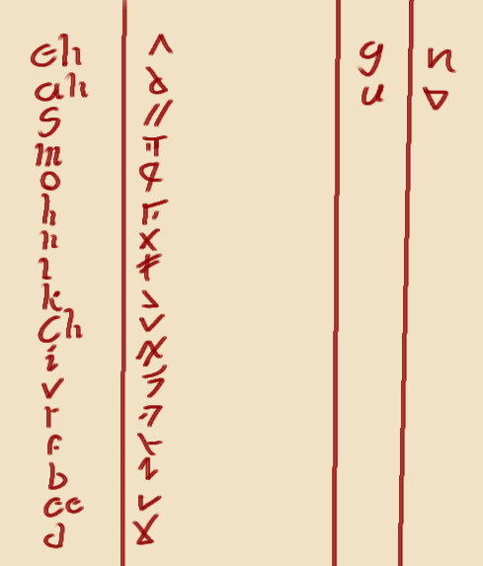

***Grammatical Rules:***

Capitalizing-Does not exist. All letters are effectively capitalized.

Nouns-refers to an object or person. While names exist, pronouns do not exist.

Past tense-Add “sak” to the end.

Present tense-Add “ki” to the end.

Future tense-Add “de” to the end.

Plural-Add “su” to the end

***Common Roots:***

So-Bio-Referring to life

Vik-Cyber-Referring to mechanical designs

Hos-Synth-Referring to the artificial

Ges-Geo-Earthen, dirt, etc

Am-Sol-Light

Ol-Mortis-Death

Gob-Big

Sen-Fre-Cold

Ga-Heat

Olu-Non-Not existent, void

Mon-Water

Ola-Bad

Sola-Good

Melo-Air

***Words:***

Me/I-Li

You-Lu

Is-Ki

Was-Sak

Will-De

The-Eel

Last-Ban

Advance-Chivra

Advancement/Advancing-Chivraki

Scale-Vin

Home-Grega

Food-Grecha

Know-Sem

Unknown-Olusem

Dead-Oln

Old-Olc

New-Nach

Existence-Eele

Order-Elem

Freedom-Mele

Structure-Elemki

Friend-Soama

Hard-Chid

Soft-Behn

Crystal-Geselem

Fast-See

Red-Gred

Blood-Gredmon

Aggressive-Gredana

Holder-Barg

Carnivore (Aquatic)-Monlagred

Fish-Monvin

“Turtle”-Monchidi

English: The man is running.  
Literal translation: Man is running.